**Data Structures and Algorithms**

**LAB 2 (Use of pointers and Dynamic Memory Allocation)**

**Name:** Ahmad Amjad Mughal

**Reg NO:** 121672

**Class:** BSCS-6C

**Task 3 Addition and Subtraction of Matrices using Array pointers**

**Source Code:**

//Ahmad Amjad Mughal

//Reg No: 121672

//Class:BSCS-6C

#include<iostream> //including library input/output stream

using namespace std; //for cin and cout statments

//Function for the Addition of two Matrices

void Addition(){

int i, j, r, d;

cout << "You have selected matrix Addition" << endl;

cout << "Enter the number of Rows of Matrices" << endl; //for No of rows of Matrices

cin >> r;

cout << "Enter the number of Columns of Matrices" << endl; //for No of columns of Matrices

cin >> d;

//2D Array Declaraion using pointers

int **a = new int*[r]; //a,b,c are pointers that points a 2D Arrays called Matrices

for (int i = 0; i < r; ++i)

a[i] = new int[d];

int **b = new int*[r];

for (int i = 0; i < r; ++i)

b[i] = new int[d];

int **c = new int*[r];

for (int i = 0; i < r; ++i)

c[i] = new int[d];

//Storing of Elements in Matix A

cout << "Enter the elements of 1st Matrix:" << endl;

for (i = 0; i < r; i++) //for loop for entering a elements in corresponding location in Matrix A

for (j = 0; j < d; j++){

cout << "Enter element a" << i + 1 << j + 1 << " : ";

cin >> a[i][j]; //Display of elements in A

}

//Storing of Elements in matrix B

cout << endl << "Enter elements of 2nd Matrix: " << endl;

for (i = 0; i < r; ++i) //for loop for entering a elements in corresponding location in Matrix B

for (j = 0; j < d; ++j){

cout << "Enter element b" << i + 1 << j + 1 << " : ";

cin >> b[i][j]; //Display of elements in B

}

//Addition of two Matrices

for (i = 0; i < r; ++i){

for (j = 0; j < d; ++j)

c[i][j] = a[i][j] + b[i][j]; //Formula for Matrix Addition

}

//Displaying of resultant matrices

cout << endl << "Sum of two matrix is: " << endl;

for (i = 0; i < r; ++i){

for (j = 0; j < d; ++j)

cout << c[i][j] << " ";

}

}

//Function for the Subtraction of two Matrices

void Subtraction()

{

int i, j, r, d;

cout << "You have selected Matrix Subtraction" << endl;

cout << "Enter the number of Rows of Matrices" << endl;

cin >> r;

cout << "Enter the number of Columns of Matrices" << endl;

cin >> d;

//2D Array Declaraion using pointers

int **a = new int*[r];

for (int i = 0; i < r; ++i)

a[i] = new int[d];

int **b = new int*[r];

for (int i = 0; i < r; ++i)

b[i] = new int[d];

int **c = new int*[r];

for (int i = 0; i < r; ++i)

c[i] = new int[d];

//Storing of Elements in Matix A

cout << "Enter the elements of 1st Matrix:" << endl;

for (i = 0; i < r; i++) //for loop for entering a elements in corresponding location in Matrix A

for (j = 0; j < d; j++){

cout << "Enter element a" << i + 1 << j + 1 << " : ";

cin >> a[i][j];

}

//Storing of Elements in matrix B

cout << endl << "Enter elements of 2nd Matrix: " << endl;

for (i = 0; i < r; ++i) //for loop for entering a elements in corresponding location in Matrix B

for (j = 0; j < d; ++j){

cout << "Enter element b" << i + 1 << j + 1 << " : ";

cin >> b[i][j];

}

//Subtraction of two Matrices

for (i = 0; i < r; ++i){

for (j = 0; j < d; ++j)

c[i][j] = a[i][j] - b[i][j]; //Formula for Matrix Subtraction

}

//Displaying of resultant matrices

cout << endl << "Diff of two matrix is: " << endl;

for (i = 0; i < r; ++i){

for (j = 0; j < d; ++j)

cout << c[i][j] << " ";

}

}

void Menu() //function Menu that is bacically for selection b/w Addition and Subtraction

{

int select;

cout << "You have an option" << endl; //prompt

cout << "Select"<< endl;

cin >> select;

if (select == 1) //if condition 1 for Matrix Subtraction 2 for Addition

{

Subtraction(); //function call Subtraction();

}

else

if (select == 2)

Addition(); //another function call Addition();

}

int main() //main function

{

cout << "You are doing Addition and Subtraction of matrices" << endl;

Menu(); //it is calling Menu function that performs selection task

return 0; //returns successfully

}

**Output:**

**For Addition**

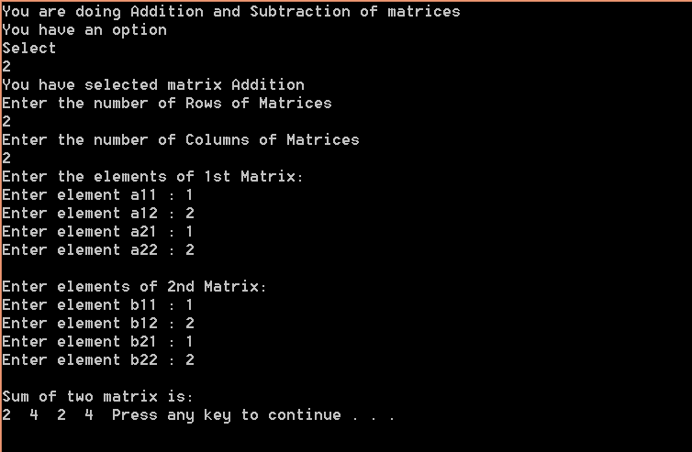

**For Subtraction**

